**The Examples of TFmini Plus on Arduino（Ⅰ）**

This application takes Uno board of Arduino as an example, reading response data from LIDAR, processing and printing measurement data through Arduino, which helps customers to quickly familiarize themselves with our company's product and reduce development cycle.

For a detailed introduction of Arduino, please refer to the following website:

official website：[www.arduino.cc](http://www.arduino.cc)

**Step 1: Hardware connection**

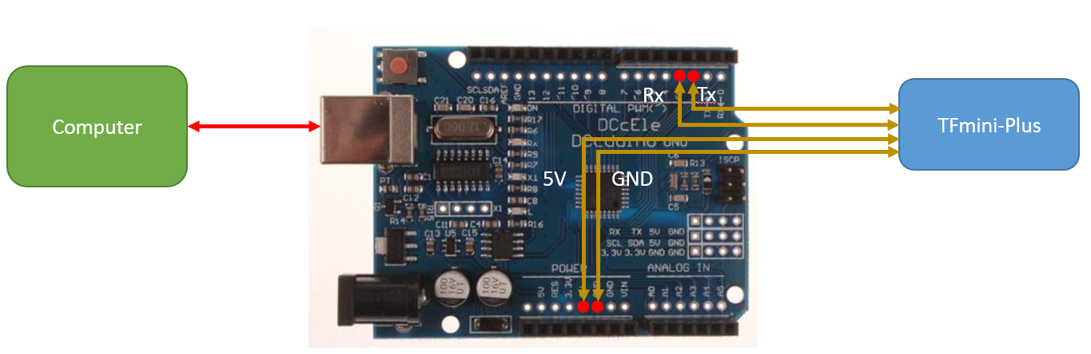

Fig.1 Wiring of TFmini Plus and UNO board

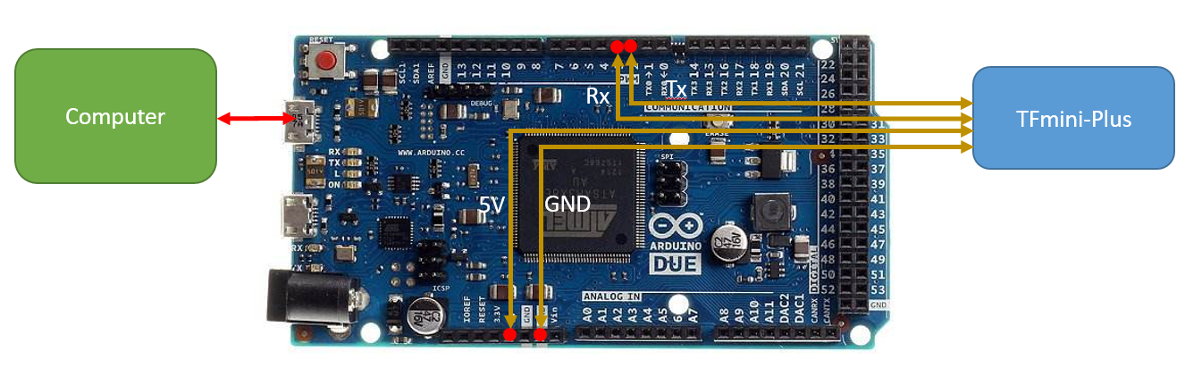

Fig.2 Wiring of TFmini Plus and DUE board

**Step 2: Programming**

The implementation of this example requires at least two serial ports of Arduino, one is for receiving lidar data and the other is for displaying data to the computer. The following code can be copied and pasted into the IDE command window.

/*

This program is the interpretation routine of standard output protocol of TFmini-Plus product on Arduino.

For details, refer to Product Specifications.

For Arduino boards with only one serial port like UNO board, the function of software visual serial port is to be used.

*/

#include <SoftwareSerial.h> //header file of software serial port

SoftwareSerial Serial1(2,3); //define software serial port name as Serial1 and define pin2 as RX and pin3 as TX

/* For Arduinoboards with multiple serial ports like DUEboard, interpret above two pieces of code and directly use Serial1 serial port*/

int dist; //actual distance measurements of LiDAR

int strength; //signal strength of LiDAR

float temprature;

int check; //save check value

int i;

int uart[9]; //save data measured by LiDAR

const int HEADER=0x59; //frame header of data package

void setup() {

Serial.begin(9600); //set bit rate of serial port connecting Arduino with computer

Serial1.begin(115200); //set bit rate of serial port connecting LiDAR with Arduino

}

void loop() {

if (Serial1.available()) { //check if serial port has data input

if(Serial1.read() == HEADER) { //assess data package frame header 0x59

uart[0]=HEADER;

if (Serial1.read() == HEADER) { //assess data package frame header 0x59

uart[1] = HEADER;

for (i = 2; i < 9; i++) { //save data in array

uart[i] = Serial1.read();

}

check = uart[0] + uart[1] + uart[2] + uart[3] + uart[4] + uart[5] + uart[6] + uart[7];

if (uart[8] == (check & 0xff)){ //verify the received data as per protocol

dist = uart[2] + uart[3] * 256; //calculate distance value

strength = uart[4] + uart[5] * 256; //calculate signal strength value

temprature = uart[6] + uart[7] *256;//calculate chip temprature

temprature = temprature/8 - 256;

Serial.print("dist = ");

Serial.print(dist); //output measure distance value of LiDAR

Serial.print('\t');

Serial.print("strength = ");

Serial.print(strength); //output signal strength value

Serial.print("\t Chip Temprature = ");

Serial.print(temprature);

Serial.println(" celcius degree"); //output chip temperature of Lidar

}

}

}

}

}

**STEP3：Data review**

Upload the sketch to the Arduino board, then open the serial monitor, It can display the measured distance and reflected strength, as shown in figure 3.

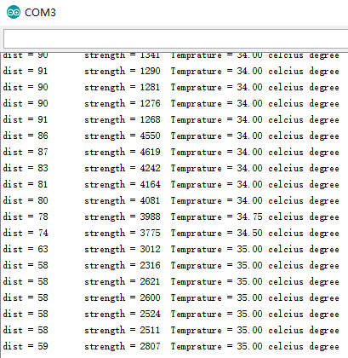

Figure 3 display the lidar data on serial monitor

In addition, you can also view the data curve on the serial port plotter, but you should modify the above code for serial port printing:

//Serial.print("dist = ");

Serial.print(dist); //output measure distance value of LiDAR

Serial.print(" ");

//Serial.print("strength = ");

Serial.print(strength); //output signal strength value

//Serial.print("\t Chip Temprature = ");

Serial.print(" ");

Serial.print(temprature);

Serial.println();

//Serial.println(" celcius degree");

Recompile and download to the Arduino board, open the serial port plotter to see the three curves representing distance, strength and temperature, as shown in Figure 4:

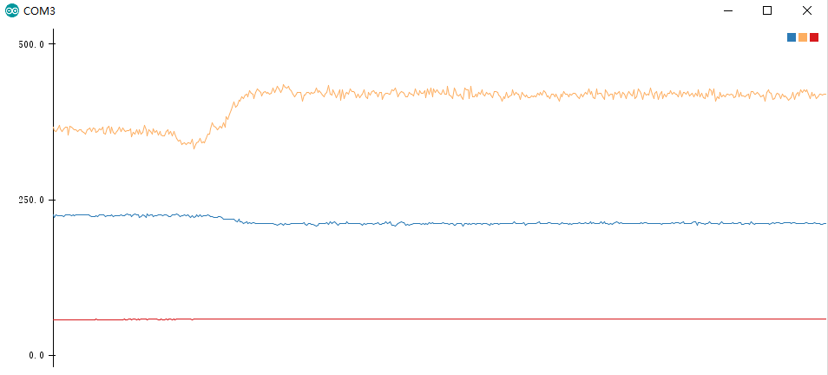

图 4 雷达数据在串口绘图器上的图像